**December 12, 2018**

**South End Rowing Club**

**Board Meeting Minutes**

**Roll call:**

|  |  |  |  |  |
| --- | --- | --- | --- | --- |
| **Member** | **Present** |  | **Member** | **Present** |
| S. Dominguez | X |  | J. Kogel | X |
| F. Hegeler | X |  | P. Moran | X |
| J. Sale | X |  | R. Moore | X |
| A. Lapp | X |  | K. Bailey | X |
| C. Merryfield | X |  | O. Gajda |  |
| N. Mortimer | X |  | S. Glazer |  |
| P. Cunneen | X |  | K. Prebil | X |
| B. Wygant |  |  | S. Blew | X |
| C. Lo | X |  |  |  |
| J. Bock | X |  | S. Wintersteen | X |

**Approval of Minutes**

Motion to approve November minutes: Board approved without revision (14 – 0 – 0).

Motion to approve 2018 Membership Meeting minutes: Board approved without revision (14 – 0 – 0).

**President’s Remarks**

Simon noted that it was both a good year and a hard year for the Board and expressed his deep appreciation to all of the Board members.

**Members Moment**

Christine Corral, requested permission to bring 16 Gateway High School students to the Club for a day as part of a week of experiential learning on the bay. The students would be allowed to row in wooden boats accompanied by experienced SERC rowers including Christine. There was some discussion about Club liability and what happens if a boat is damaged. Christine assured the Board that students and their parents would take responsibility. A motion was made to approve the request subject to Simon reviewing and approving a copy of the liability waiver. The motion passed (11 – 0 – 3).

Marc Brandt addressed the Board on the subject of creating secure storage for small personal items. Mark has been a member since 2005 and used to have a locker which he eventually gave up. Mark suggested a new storage option be created suitable for storing small items like a wallet, phone, jewelry, etc. These personal storage units would be short term (i.e., no overnight storage) and available on a first-come, first-serve basis. They wouldn’t need to be placed in the locker rooms, in fact they could even be outside. Board members thought this was an interesting idea worth exploring.

1. **2019 Budget**

Susan would like to adopt the 2019 budget earlier than was done in 2018. She is providing each commissioner a detailed breakdown of their 2018 revenue and spending. She would like outgoing commissioners to help incoming commissioners develop their 2019 budgets. She is available to meet one-on-one with anybody needing help.

Susan suggested a budget work session at the January meeting that is mostly focused on how each program’s 2019 budget will be different than 2018’s (i.e., deltas). Also a prioritized list of desired capital expenditures for 2019 should be created. Until you hear otherwise from Susan, assume 2019 funding levels will be similar to 2018.

The goal would be to adopt the budget at the February Board meeting.

1. **New Board Member Contact Details**

Please remember to get contact details for incoming 2019 Board members to Josh.

1. **Membership Report**

We’re up to 1535 members. Kathy reported that historically the 50 and 60 year old categories (379 and 286 members respectively) were the two largest categories but the 30 and 40 year old categories are catching up (262 and 264). We’re getting bigger, younger and older at the same time!

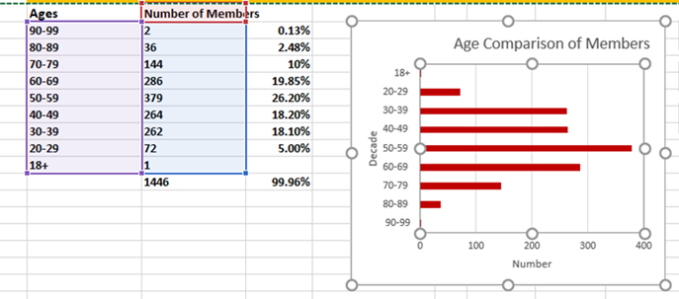

*Approx. 100 members do not report birthdate.

Kathy reported that about 15% of the 2018 membership had renewed for 2019 at the time of the meeting.

Susan indicated that one of the most frequent questions to the Club was “how do I join?” She suggested that a link to the membership application be given more prominent placement on the website. This task was assigned to Sarah and Kelley.

1. **Calendar review**

Jane walked us through the calendar for the remainder of 2018.

**Holiday Party Recap (not on agenda)**

Jane reported that the holiday party ended with a $5300 surplus! 320 people attended all were extremely well fed by Al and his kitchen team (who btw came in $611 under budget). Jane reported that the awards ceremony was even briefer than hoped.

Everybody lauded Jane for pulling off another fabulous soiree!

This was Jane’s last rodeo as Entertainment Commissioner and she introduced her replacement Betty Jean Jaurique.

**Voting Problems (not on agenda)**

Rory reported that some members were having problems with online voting and asked if paper ballots could be placed at the front door. Anybody having problems voting should get in contact with Sue Free who is directing the election.

**Holiday Cleaning Schedule (not on agenda)**

Jim reported that the cleaning crew had been given Christmas eve, Christmas day, New Years eve and New Years day off.

**Sign at Back of Club (not on agenda)**

Pat has been investigating the creation of a sign to be installed at the back of the Club. After looking at various expensive options, he and Al came up with a new plan to create a sign for approximately $250 plus some Boat Night labor.

**2018 Board Appreciation (not on agenda)**

Simon again expressed his appreciation to all the 2018 Board members. He bid a final thanks to those who won’t be returning and expressed hope for a good 2019 to those coming back.

Each Board member received a lovely commemorative gift from Simon and Fran presented a gift to Simon and thanked him for his leadership in 2018.

The Board adjourned to dinner at the Franciscan Crab Restaurant.